To be read with the ‘Risk Assessment Guide’ which will set out how the form should be completed and the University and Students’ Union’s approach to risk assessment. If you have any questions, please seek advice from the Student Activities Manager or BUCS Sport Administrator (Sports Clubs) or the Student Groups Assistant or Student Communities Coordinator (Societies, Networks, Volunteering & Fundraising). Once completed, the control measures must be adhered to.

Note:

Brief description of the activity being assessed (include dates of event, and likely number of attendees)

Location: | UW Wide Office (general activities) | Risk Assessor (name/committee position):
Student Group: |  | Date of Assessment:
Risk Assessment Reference & Version |  | Date of Review
Other people (s) commenting on this assessment (where required) | Name  Date |  | Approved by  Date
Process of communicating to relevant persons

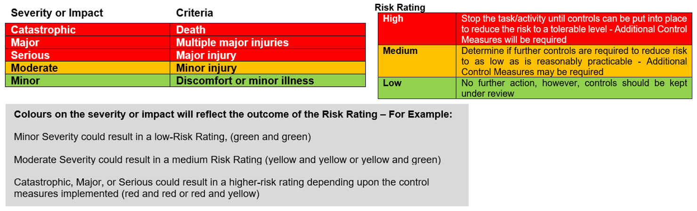

Hazards  (A hazard is something that can cause harm, e.g. electricity, chemicals, working up a ladder, noise, car, DSE) | People at Risk  (Students, Staff, Visitors, Contractors, Other) | What harm might occur,  (Slips Trips, Falls, Breaks, Sprains etc…) | Control Measures already in place  (Control measures include actions that can be taken to reduce the potential of exposure to the hazard). | Evaluate the Risk  (Having identified the hazards and controls, decide how likely it is that harm will occur), | Additional Control Measures  (Only necessary when additional controls are required.  These controls form part of the standard control measures when implemented.) | Revaluate the risk  By adding the additional controls, has the rating changed?
Electrical equipment | Students | Burns,  Electrical Shocks | - UW has a current electrical condition certificate in place.  - All items of portable electrical equipment are subject to a periodic inspection and testing on a risk-based approach.  - Regular visual inspections of the condition of electrical equipment are made by staff in order to identify kinked or damaged flex and cables, damaged plugs or sockets, burn or scorch marks and the general condition of the equipment.  - Damaged electrical equipment should be removed from use immediately and reported to IT. | Low | Suitable controls are in  place, however, this  will be monitored and  any areas that need  actioning will be  considered and  implemented. | Low
Manual Handling | Students | Back Pain, sprains, strains and other  musculoskeletal  conditions | - Students should not be moving heavy equipment without basic manual handling instruction, information and training.  - Students are instructed not to attempt to lift items that approach the limits of their capabilities. | Low | Suitable controls are in  place, however, this  will be monitored and  any areas that need  actioning will be  considered and  implemented. | Low
Furniture and fixtures | Students | Various injuries as a result of poorly maintained equipment | - Permanent fixtures e.g., cupboards, shelving, display boards, and interactive white screens are securely fastened and in a good state of repair. These are monitored by users and issues are reported using the information available on the "your space" posters displayed in the areas | Low | Suitable controls are in  place, however, this  will be monitored and  any areas that need  actioning will be  considered and  implemented. | Low
Viral & Bacterial Infections | Students | Flu like  symptoms,  norovirus,  respiratory,  infections such as  covid, monkey  pox | - Review the current status of viral infections and follow the advice provided by the UK Health Security Agency (UKHSA) and take steps accordingly.  - Opening windows for 10 minutes every hour will significantly reduce the risk of those in the room windows do not need to be open all the time to improve ventilation. Bringing fresh air into a room by opening a door or a window even for a few minutes at a time helps remove older stale air that could contain virus particles and reduces the chance of spreading infections | Medium | Suitable controls are in place, however, this will be monitored and any guidance from the UK Health Security Agency & UEB will be implemented. | Medium
Lone/Late Working | Students | Acts of aggression | - All computers and key locations have access to the phone Via MS Teams to call for assistance from security on 01905 855495 or 07977973956  - Students are encouraged to take up the "Call my Alert" app. The SOS button will alert the security desk who can send a member of staff to support/resolve any conflict. | Low | Suitable controls are in  place, however, this  will be monitored and  any areas that need  actioning will be  considered and  implemented. | Low
Weather | Students | Temperature  related  conditions, eye  strain, heat  exhaustion, chill  etc | - Natural ventilation is provided by opening windows & forced ventilation system.  - Central heating system is capable of maintaining suitable winter temperatures provided. System subject to routine maintenance.  - Air conditioning units are provided in a number of locations (not all). Subject to annual maintenance  - Suitable measures with blinds etc. to prevent glare and heat from the sun.  - Updates from the Comms team regarding coping in hot/cold temperatures are in place to remind staff and students of the best way of working. (Such as loose clothing, drinking more etc..) | Low | Suitable controls are in  place, however, this  will be monitored and  any areas that need  actioning will be  considered and  implemented. | Low

Action Ref | Action required | Who is responsible? | By when? | Date completed / Comments

