To be read with the ‘Risk Assessment Guide’ and ‘Hazard Checklist’ which will set out how the form should be completed and the University and Students’ Union’s approach to risk assessment. If you have any questions, please seek advice from the Student Activities Manager or BUCS Sport Administrator (Sports Clubs) or the Student Activities Administrator (Societies, Networks, Volunteering & Fundraising). Once completed, the control measures must be adhered to.

Please note, this template has been created as a tool to assist you in assessing the risk of your activity. It is not a completed version. Please read through carefully and delete anything in red that is not relevant to your activity or provide further information in context to your activity.

Tracked Changes have been applied to this document so that SU staff can review your edits to the template.

Note:

Please enter a brief description of the activity being assessed (include dates of event, and likely number of attendees):

Location: |  | Risk Assessor (name/committee position):
Student Group: |  | Date of Assessment:
Risk Assessment Reference & Version |  | Date of Review
Other people (s) commenting on this assessment (where required) |  |  | Approved by
Process of communicating to relevant persons

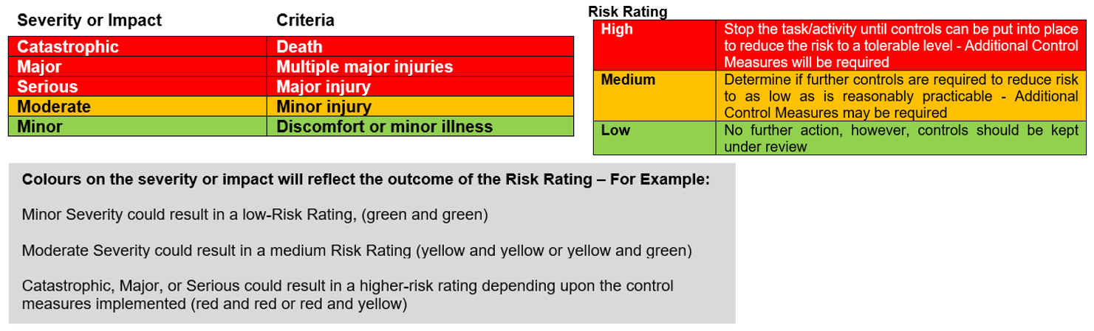

Hazards  (A hazard is something that can cause harm, e.g. electricity, chemicals, working up a ladder, noise, car, DSE) | People at Risk  (Students, Staff, Visitors, Contractors, Other) | What harm might occur,  (Slips Trips, Falls, Breaks, Sprains etc…) | Control Measures already in place  (Control measures include actions that can be taken to reduce the potential of exposure to the hazard). | Evaluate the Risk  (Having identified the hazards and controls, decide how likely it is that harm will occur), | Additional Control Measures  (Only necessary when additional controls are required.  These controls form part of the standard control measures when implemented.) | Revaluate the risk  By adding the additional controls, has the rating changed?
Venue Hazards
Hazards associated with venue (3G)  E.g.,  - Surface  - Football Posts and Nets  - Small Football Goals  - Other equipment | Players, Spectators | Risk associated with slips, trips & Falls, | Sport Facilities has their own risk assessment. 3G is deemed a playable surface, so risk of trips etc will be limited.  Committee to perform a pitch inspection before starting a warm up.  If there is any equipment obstructing the pitch and the side lines to report it to the Sport Centre reception. Do not commence activity until a UW Sport Supervisors confirms the obstruction has been moved.  If anyone needs first aid, immediately report to sport centre reception on St John's where a UW Sport Supervisor will provide first aid and report any incidents. | Medium | Suitable controls are in place; however, this will be monitored and any areas that need actioning will be considered and implemented. | Medium
Equipment/Personal Belongings | Players, Spectators | Trip over, breaks, sprains | Any equipment and any personal belongings of those taking part will be out of the way of players and guests. | Low | Suitable controls are in place; however, this will be monitored and any areas that need actioning will be considered and implemented | Low
[insert here any other hazards associated to your event that fall under this category]
[insert here any other hazards associated to your event that fall under this category]
[insert here any other hazards associated to your event that fall under this category]
Environmental
Weather | Players/Spectators | Dehydration, heatstroke, sunburn Hypothermia, pneumonia | In the event of warm weather:  - Regular Breaks and Access to Drinking Water  In the event of thunder and lightning:  - Play will be suspended until 15 minutes after the last thunder  Game will be postponed if adverse weather is forecasted. | Low | Suitable controls are in place; however, this will be monitored and any areas that need actioning will be considered and implemented | Low
Low lighting | Players/Spectators | Unable to see hazards/other players, slips, trips and falls | Football pitch has flood lights.  If the flood lights are not working, to report to the Sport Centre Reception who will investigate. | Low | Suitable controls are in place; however, this will be monitored and any areas that need actioning will be considered and implemented | Low
Cash Handling [Delete if not appropriate]
Money Handling | Staff, Committee members | Misplacing/ losing charity money. | - Money not to be left unattended at any time, including card machine, cash bucket and if using, float.  - Tickets will be purchased online or through using the card machine on the door  - Any cash donations will be placed in a zip locked charity bucket which will follow SU procedures. This will be kept with a committee member at all times.  - Designated committee member responsible for signing out the card machine and cash bucket and returning to the SU as soon as possible after the event has finished to be kept safe in the office.  - Charity bucked will be kept zip locked shut and counted by the SU. | Low | Suitable controls are in place; however, this will be monitored and any areas that need actioning will be considered and implemented | Low
[insert here any other hazards associated to your event that fall under this category]
Hazards Associated with the Event/Activity
Not warming up properly. | Players | Injuries such as sprains, strains | Players will take part in a warm-up organised by nominated committee member. | Low | Suitable controls are in place; however, this will be monitored and any areas that need actioning will be considered and implemented | Low
Physical Exertion | Players | Overexertion causing exhaustion, dehydration and injury. | Everyone will be reminded to bring a drink so they can stay hydrated throughout the game.  Regular subs will be made. Players on the pitch to signal if they need to sub off.  Those with asthma will be reminded to take their inhalers.  There will 11 on each side (22 players on the pitch altogether), there will be unlimited substitutions during the 90-minute match | Medium | Suitable controls are in place; however, this will be monitored and any areas that need actioning will be considered and implemented | Medium
Inexperienced Players | Players | Overexertion,  Injury | Some members participating in the game will be inexperienced in playing football or may not regularly play. [The offside rule will not be included during game play and slide tackles will be forbidden.]  The rules will be told to players prior to the game. An experienced player will referee the game and use FA rules unless both teams agree to adaptions to make it more accessible.  There will be unlimited substitutions so players can come off any point and return to the game. | Medium | Suitable controls are in place; however, this will be monitored and any areas that need actioning will be considered and implemented | Medium
[insert here any other hazards associated to your event that fall under this category]
[insert here any other hazards associated to your event that fall under this category]
People/Social Events
Unsafe behaviour or attitude | Players/Spectators | Harm to self or others | - Staff to be informed who will be responsible for controlling unruly behaviour.  - Security on site during the event if required (07977973956 / 01905 855495)  - SU Code of Conduct in place with zero tolerance. SU investigate immediately after any incident.  - Sanctions issued to students as needed | Low | Suitable controls are in place; however, this will be monitored and any areas that need actioning will be considered and implemented. | Low
Inappropriate clothing and footwear. | Players | Falls / injuries. | Committee will provide players with a list of what is classed as appropriate clothing/footwear for the event, and what protective kit they need to bring, if players are not dressed correctly, they will not be allowed to play. | Low | Suitable controls are in place; however, this will be monitored and any areas that need actioning will be considered and implemented | Low
Spectator Event | Players/Spectators | Overcrowding, crushing, negative impact on wellbeing | Event is being hosted at UW 3G pitch which has a big area for spectators expected for this event.  If there are concerns about number of spectators, an event leader is to alert sport centre reception who can help to crowd control or alert security | Low | Suitable controls are in place; however, this will be monitored and any areas that need actioning will be considered and implemented | Low
[insert here any other hazards associated to your event that fall under this category]
First Aid
Provision of First Aid | Players/Spectators | Broken bones, Cuts Eye injuries Sprains, allergic reaction | If anyone needs first aid, immediately report to sport centre reception on St John's where a UW Sport Supervisor will provide first aid and report any incidents. | Medium | Suitable controls are in place; however, this will be monitored and any areas that need actioning will be considered and implemented. | Medium

Action Ref | Action required | Who is responsible? | By when? | Date completed / Comments
01 | Complete pitch inspection | [insert committee member name] | [insert date]
02 | Request card machine/charity buckets, collect and return | [insert committee member name] | [insert date]
03 | Complete warm up | [insert committee member name] | [insert date]
04 | Participant pre-event information sent including reminders to  - Bring a drink  - List of classified appropriate footwear/clothing  - Protective kit (shinpads) | [insert committee member name] | [insert date]
05 | Complete kit inspection | [insert committee member name] | [insert date]
06 | Complete Event Request Form and request tickets to be set up | [insert committee member name] | [insert date]
07 | [Insert here any other actions you have identified to ensure your control measures are in place]

