To be read with the ‘Risk Assessment Guide’ and ‘Hazard Checklist’ which will set out how the form should be completed and the University and Students’ Union’s approach to risk assessment. If you have any questions, please seek advice from the Student Activities Manager or BUCS Sport Administrator (Sports Clubs) or the Student Activities Administrator (Societies, Networks, Volunteering & Fundraising). Once completed, the control measures must be adhered to.

Please note, this template has been created as a tool to assist you in assessing the risk of your activity. It is not a completed version. Please read through carefully and delete anything in red that is not relevant to your activity or provide further information in context to your activity.

Tracked Changes have been applied to this document so that SU staff can review your edits to the template.

To be read with the ‘Risk Assessment Guide’ and ‘Hazard Checklist’ which will set out how the form should be completed and the University and Students’ Union’s approach to risk assessment. If you have any questions, please seek advice from the Student Activities Manager or BUCS Sport Administrator (Sports Clubs) or the Student Activities Administrator (Societies, Networks, Volunteering & Fundraising). Once completed, the control measures must be adhered to.

Please note, this template has been created as a tool to assist you in assessing the risk of your activity. It is not a completed version. Please read through carefully and delete anything in red that is not relevant to your activity or provide further information in context to your activity.

Note:

Please enter a brief description of the activity being assessed (include dates of event, and likely number of attendees):

Location: |  | Risk Assessor (name/committee position):
Student Group: |  | Date of Assessment:
Risk Assessment Reference & Version |  | Date of Review
Other people (s) commenting on this assessment (where required) | Name  Date |  | Approved by  Date
Process of communicating to relevant persons

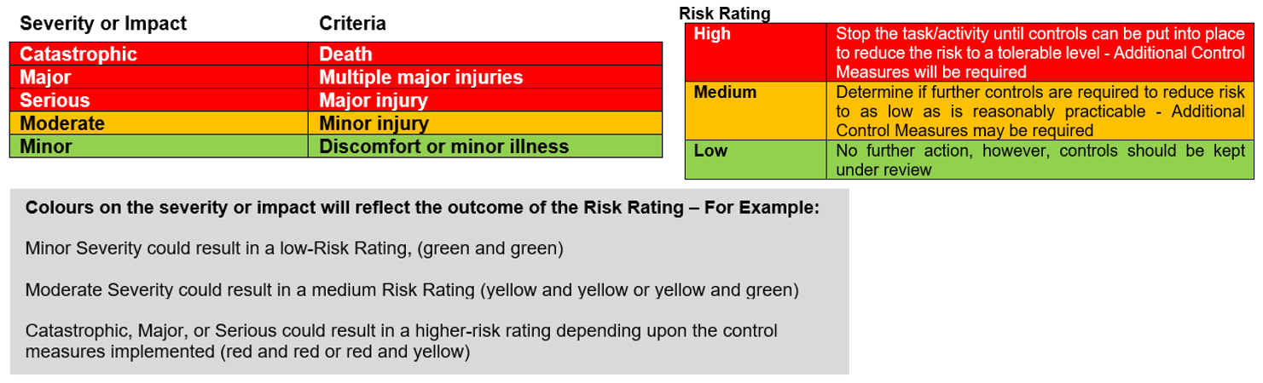

Hazards  (A hazard is something that can cause harm, e.g. electricity, chemicals, working up a ladder, noise, car, DSE) | People at Risk  (Students, Staff, Visitors, Contractors, Other) | What harm might occur,  (Slips Trips, Falls, Breaks, Sprains etc…) | Control Measures already in place  (Control measures include actions that can be taken to reduce the potential of exposure to the hazard). | Evaluate the Risk  (Having identified the hazards and controls, decide how likely it is that harm will occur), | Additional Control Measures  (Only necessary when additional controls are required.  These controls form part of the standard control measures when implemented.) | Revaluate the risk  By adding the additional controls, has the rating changed?
Venue Hazards
Hazards associated with venue (The Hangar)  - Furniture and Fixtures  - Environmental  - Uneven, wet or slippery floors  - Fire | Students,  Staff,  Visitors,  Contractors,  Volunteers | Risk associated with slips, trips & falls, | The Hangar have own risk assessment.  Hangar staff will be present.  All present must abide to instructions from The Hangar or SU staff and all venue rules.  Any individual who breaches the rules or does not follow instruction will be asked to leave. University of Worcester Security will be called if necessary to escort the individual off the premises. | Medium | Suitable controls are in place; however, this will be monitored and any areas that need actioning will be considered and implemented | Medium
Electrical hazards | Students,  Staff,  Visitors,  Contractors,  Volunteers | Burns  Electrical Shocks | - All electrical equipment has been approved by the Hangar Team  - UW has a current electrical condition certificate in place.  - All items of portable electrical equipment brought in by the student group/individual/contractor/volunteer should be PAT test unless new (under a year old).  - Equipment to be visually inspected before use  - Damaged electrical equipment should be removed from use immediately and reported using a suitable, documented hazard reporting procedure.  - Only trained people to handle any high-risk, specialised electrical equipment  - Electrical Set Up to be located in one area away from guests | Low | Suitable controls are in place; however, this will be monitored and any areas that need actioning will be considered and implemented | Low
Manual Handling | Students,  Staff,  Visitors,  Contractors,  Volunteers | Muscle strains, bruising or bone breakages | Only The Hangar trained staff to move heavy furniture or equipment. | Low | Suitable controls are in place; however, this will be monitored and any areas that need actioning will be considered and implemented | Low
Equipment/Personal Belongings | Students,  Staff,  Visitors,  Contractors,  Volunteers | Trip over, breaks, sprains | Any equipment and any personal belongings of those running the event will be out of the way of guests.  If any furniture or fixtures belonging to the venue require moving, to request Hangar Staff to move it. | Low | Suitable controls are in place; however, this will be monitored and any areas that need actioning will be considered and implemented | Low
[insert here any other hazards associated to your event that fall under this category]
[insert here any other hazards associated to your event that fall under this category]
[insert here any other hazards associated to your event that fall under this category]
Cash Handling [Delete if not appropriate]
Money Handling | Staff, Committee members | Misplacing/ losing charity money. | - Money not to be left unattended at any time, including card machine, cash bucket and if using, float.  - Tickets will be purchased online or through using the card machine on the door  - Any cash donations will be placed in a zip locked charity bucket which will follow SU procedures. This will be kept with a committee member at all times.  - Designated committee member responsible for signing out the card machine and cash bucket and returning to the SU as soon as possible after the event has finished to be kept safe in the office.  - Charity bucked will be kept zip locked shut and counted by the SU. | Low | Suitable controls are in place; however, this will be monitored and any areas that need actioning will be considered and implemented | Low
[insert here any other hazards associated to your event that fall under this category]
Hazards Associated with the Event/Activity
[insert here any other hazards associated to your event that fall under this category]
[insert here any other hazards associated to your event that fall under this category]
[insert here any other hazards associated to your event that fall under this category]
People/Social Events
Consuming alcoholic drinks | Students,  Staff,  Visitors,  Contractors,  Volunteers | Falls, inappropriate behaviour | Member of staff who is first aid trained will be present.  The Hangar is a licenced venue and will follow their protocol with serving alcoholic drinks. | Low | Suitable controls are in place; however, this will be monitored and any areas that need actioning will be considered and implemented | Low
Unsafe behaviour or attitude | Students,  Staff,  Visitors,  Contractors,  Volunteers |  | - Staff to be informed who will be responsible for controlling unruly behaviour.  - Security on site during the event if required (07977973956 / 01905 855495)  - SU Code of Conduct in place with zero tolerance. SU investigate immediately after any incident.  - Sanctions issued to students as needed | Low | Suitable controls are in place; however, this will be monitored and any areas that need actioning will be considered and implemented | Low
Crowding | Students,  Staff,  Visitors,  Contractors,  Volunteers | Crushing Minor Injury Overcrowding in designated area Tripping | Venue Capacity will be abided to (this will be confirmed by the venue manager).  [Ticket sales will be limited to the venue capacity number. Once capacity is limited, no more tickets will be available] | Low | Suitable controls are in place; however, this will be monitored and any areas that need actioning will be considered and implemented. | Low
[insert here any other hazards associated to your event that fall under this category]
First Aid
Provision of First Aid | Students,  Staff,  Visitors,  Contractors,  Volunteers | Broken bones, Cuts Eye injuries Sprains, allergic reaction | First Aid Trained Member of Hangar Staff will be available during the event who will also report the incident/accident. | Medium | Suitable controls are in place; however, this will be monitored and any areas that need actioning will be considered and implemented. | Medium

Action Ref | Action required | Who is responsible? | By when? | Date completed / Comments
01 | Request card machine/charity buckets, collect and return | [insert committee member name] | [insert date]
02 | Complete Event Request Form and request tickets to be set up | [insert committee member name] | [insert date]
03 | [Insert here any other actions you have identified to ensure your control measures are in place]
04
05
06
07

