To be read with the ‘Risk Assessment Guide’ and ‘Hazard Checklist’ which will set out how the form should be completed and the University and Students’ Union’s approach to risk assessment. If you have any questions, please seek advice from the Student Activities Manager or BUCS Sport Administrator (Sports Clubs) or the Student Activities Administrator (Societies, Networks, Volunteering & Fundraising). Once completed, the control measures must be adhered to.

Please note, this template has been created as a tool to assist you in assessing the risk of your activity. It is not a completed version. Please read through carefully and delete anything in red that is not relevant to your activity or provide further information in context to your activity.

Tracked Changes have been applied to this document so that SU staff can review your edits to the template.

To be read with the ‘Risk Assessment Guide’ and ‘Hazard Checklist’ which will set out how the form should be completed and the University and Students’ Union’s approach to risk assessment. If you have any questions, please seek advice from the Student Activities Manager or BUCS Sport Administrator (Sports Clubs) or the Student Activities Administrator (Societies, Networks, Volunteering & Fundraising). Once completed, the control measures must be adhered to.

Please note, this template has been created as a tool to assist you in assessing the risk of your activity. It is not a completed version. Please read through carefully and delete anything in red that is not relevant to your activity or provide further information in context to your activity.

Note:
Please enter a brief description of the activity being assessed (include dates of event, and likely number of attendees)

Location: |  | Risk Assessor (name/committee position):
Student Group: |  | Date of Assessment:
Risk Assessment Reference & Version |  | Date of Review
Other people (s) commenting on this assessment (where required) | Name  Date |  | Approved by  Date
Process of communicating to relevant persons | Emails
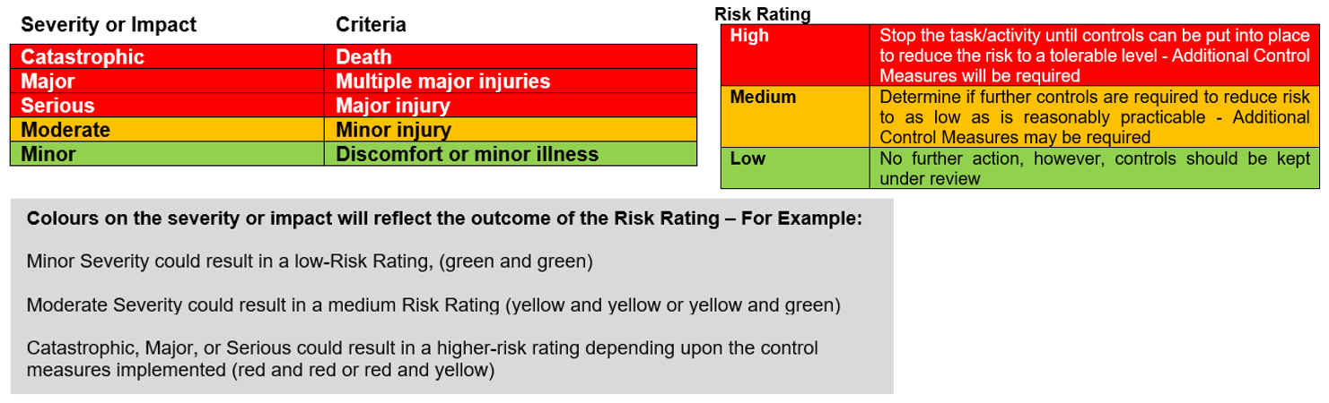

Hazards  (A hazard is something that can cause harm, e.g. electricity, chemicals, working up a ladder, noise, car, DSE) | People at Risk  (Students, Staff, Visitors, Contractors, Other) | What harm might occur,  (Slips Trips, Falls, Breaks, Sprains etc…) | Control Measures already in place  (Control measures include actions that can be taken to reduce the potential of exposure to the hazard). | Evaluate the Risk  (Having identified the hazards and controls, decide how likely it is that harm will occur), | Additional Control Measures  (Only necessary when additional controls are required.  These controls form part of the standard control measures when implemented.) | Revaluate the risk  By adding the additional controls, has the rating changed?
Venue Hazards
Electrical Equipment | Students | Burns  Electrical Shocks | - UW has a current electrical condition certificate in place.  - All items of portable electrical equipment brought in by the society should be PAT test unless new (under a year old).  - Damaged electrical equipment should be removed from use immediately and reported using a suitable, documented hazard reporting procedure. | Low | Suitable controls are in place; however, this will be monitored and any areas that need actioning will be considered and implemented. | Low
Furniture and fixtures | Students | Various injuries as a result of poorly maintained equipment | Permanent fixtures e.g. cupboards, shelving, display boards, and interactive white screens are securely fastened and in a good state of repair. Any damage should be report to the SU so we can onwards report to the University | Low | Suitable controls are in place; however, this will be monitored and any areas that need actioning will be considered and implemented. | Low
Uneven, Wet or Slippery Floors | Students | Slips, trips, falls, striking objects resulting in bruising, tissue damage, fractures etc. | - Sufficient, bright lighting is provided to illuminate pedestrian routes, access and egress.  - Procedures are in place to deal with spillages.  - Access stairs or ramps are provided with handrails.  - Floors and flooring is maintained in a good state of repair. A hazardous condition reporting procedure allows staff to raise concerns for action whenever an unsafe condition is spotted.  - Changes in floor level are highlighted.  - Gangways and walkways are kept clear of chairs, desks, bags and other obstructions  - Trailing electrical leads are kept to a minimum and routed along walls and behind furniture. Where cables need to cross walkways pedestrian cable covers, or mats are used. | Medium | Suitable controls are in place; however, this will be monitored and any areas that need actioning will be considered and implemented. | Medium
Environmental | Students | Temperature related conditions, eye strain, heat exhaustion, chill etc. | - Natural ventilation is provided by opening windows & forced ventilation system.  - Central heating system is capable of maintaining suitable winter temperatures provided. System subject to routine maintenance.  - Air conditioning units are provided in a number of locations (not all). Subject to annual maintenance  - Suitable measures with blinds etc. to prevent glare and heat from the sun. | Medium | Suitable controls are in place; however, this will be monitored and any areas that need actioning will be considered and implemented. | Medium
Hazards Associated with the Event/Activity
Money Handling | Staff, Committee members | Misplacing/ losing charity money. | - Money not to be left unattended at any time, including card machine, cash bucket and if using, float.  - Tickets will be purchased online or through using the card machine on the door  - Any cash donations will be placed in a zip locked charity bucket which will follow SU procedures. This will be kept with a committee member at all times.  - Designated committee member responsible for signing out the card machine and cash bucket and returning to the SU as soon as possible after the event has finished to be kept safe in the office.  - Charity bucked will be kept zip locked shut and counted by the SU. | Low | Suitable controls are in place; however, this will be monitored and any areas that need actioning will be considered and implemented | Low
[insert here any other hazards associated to your event that fall under this category]
[insert here any other hazards associated to your event that fall under this category]
People/Social Events
Students (Violence, threatening behaviour) | Students | Acts of aggression | - Staff to be informed who will be responsible for controlling unruly behaviour.  - Security on site during the event if required (07977973956 / 01905 855495)  - SU Code of Conduct in place with zero tolerance. SU investigate immediately after any incident.  - Sanctions issued to students as needed | Low | Suitable controls are in place; however, this will be monitored and any areas that need actioning will be considered and implemented. | Low
Hot Liquids (tea, coffee etc..) | Students | Burns, Slips trip and fall | - Persons using hot drinks purchased from the café are reminded to transport the drink with the lid securely fitted.  - 2. Any spillages are cleaned up immediately | Medium | Suitable controls are in place; however, this will be monitored and any areas that need actioning will be considered and implemented. | Medium
Crowding | Students, Staff, Visitors, Volunteers | Crushing Minor Injury Overcrowding in designated area Tripping | Room Capacity will be abided to (this can be found via UW Room Booking Portal). If a bigger room is required, request through SU Activities team. | Low | Suitable controls are in place; however, this will be monitored and any areas that need actioning will be considered and implemented. | Low
[insert here any other hazards associated to your event that fall under this category]
First Aid
Provision of First Aid | Students,  Staff,  Visitors,  Contractors,  Volunteers | Broken bones, Cuts Eye injuries Sprains, allergic reaction | First Aid Trained Member of [University of Worcester Security Staff] will be available during the event who will also report the incident/accident. | Medium | Suitable controls are in place; however, this will be monitored and any areas that need actioning will be considered and implemented. | Medium

Action Ref | Action required | Who is responsible? | By when? | Date completed / Comments
01 | Complete Room Booking Request through SU
02 | Request card machine/charity buckets, collect and return | [insert committee member name] | [insert date]
03 | [Insert here any other actions you have identified to ensure your control measures are in place]
04
05
06
07

