To be read with the ‘Risk Assessment Guide’ and ‘Hazard Checklist’ which will set out how the form should be completed and the University and Students’ Union’s approach to risk assessment. If you have any questions, please seek advice from the Student Activities Manager or BUCS Sport Administrator (Sports Clubs) or the Student Activities Administrator (Societies, Networks, Volunteering & Fundraising). Once completed, the control measures must be adhered to.

Please note, this template has been created as a tool to assist you in assessing the risk of your activity. It is not a completed version. Please read through carefully and delete anything in red that is not relevant to your activity or provide further information in context to your activity.

Tracked Changes have been applied to this document so that SU staff can review your edits to the template.

To be read with the ‘Risk Assessment Guide’ and ‘Hazard Checklist’ which will set out how the form should be completed and the University and Students’ Union’s approach to risk assessment. If you have any questions, please seek advice from the Student Activities Manager or BUCS Sport Administrator (Sports Clubs) or the Student Activities Administrator (Societies, Networks, Volunteering & Fundraising). Once completed, the control measures must be adhered to.

Please note, this template has been created as a tool to assist you in assessing the risk of your activity. It is not a completed version. Please read through carefully and delete anything in red that is not relevant to your activity or provide further information in context to your activity.

Note:

Enter a brief description of the activity being assessed (include dates of event, and likely number of attendees)

Location: |  | Risk Assessor (name/committee position):
Student Group: |  | Date of Assessment:
Risk Assessment Reference & Version |  | Date of Review
Other people (s) commenting on this assessment (where required) | Name  Date |  | Approved by:  Date:
Process of communicating to relevant persons

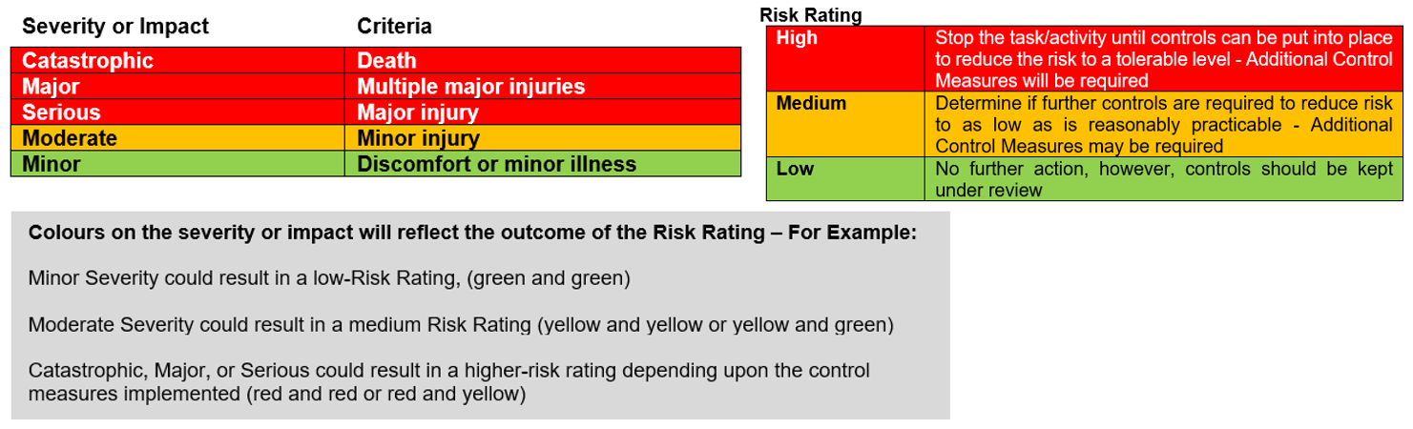

Hazards  (A hazard is something that can cause harm, e.g. electricity, chemicals, working up a ladder, noise, car, DSE) | People at Risk  (Students, Staff, Visitors, Contractors, Other) | What harm might occur,  (Slips Trips, Falls, Breaks, Sprains etc…) | Control Measures already in place  (Control measures include actions that can be taken to reduce the potential of exposure to the hazard). | Evaluate the Risk  (Having identified the hazards and controls, decide how likely it is that harm will occur), | Additional Control Measures  (Only necessary when additional controls are required.  These controls form part of the standard control measures when implemented.) | Revaluate the risk  By adding the additional controls, has the rating changed?
Environmental
Weather Conditions | Students | Hypothermia, hyperthermia, sunburn, sunstroke | Weather will be checked day before the event and appropriate accommodations will be made i.e., suncream advised, sitting in shade, asking attendees to bring water with them. | Low | Suitable controls are in place; however, this will be monitored and any areas that need actioning will be considered and implemented. | Low
Uneven Floor | Students | Slip, trip, falls | Location of picnic has been selected in an area of even ground and in a visible space.  Medibag which contains first aid supplies for student group activities will be collected from the SU prior to the event. | Low | Suitable controls are in place; however, this will be monitored and any areas that need actioning will be considered and implemented. | low
Hazards Associated with the Event/Activity
Allergic Reaction | Students | Allergic reactions, including anaphylaxis and possibly death | - Event leads have completed food & allergen training. https://allergytraining.food.gov.uk/  - Ingredients of food should be listed on the package bought items so students can make an informed decision about what they are eating. In the event of an allergic reaction, call 999 immediately.  - Allergen-free food options will be kept separate from other items to avoid cross-contamination. | Medium | Suitable controls are in place; however, this will be monitored and any areas that need actioning will be considered and implemented. | Medium
Food Handling, Food Poisoning, Food Hygiene [no homemade food, delete if not appropriate] | Students | Allergic reactions, food poisoning | - Only shop-bought snack food like biscuits, crisps, chocolate, soft drinks, cakes etc with allergens displayed on packing will be available. No homemade items.  - Sell by date and condition will be checked before eating.  - Perishable foods will be disposed after two hours of being taken out the refrigerator.  - In the event that someone vomits, volunteers to follow WSU Risk Assessment for cleaning bodily fluids (Appendix B) | Medium | Suitable controls are in place; however, this will be monitored and any areas that need actioning will be considered and implemented. | Medium
Food Handling, Food Poisoning, Food Hygiene [homemade cold food e.g cakes sandwiches, delete if not appropriate] | Students | Allergic reactions, food poisoning | - All volunteers baking sent SU Food Preparations guidelines to read through (Appendix A).  - Check sell-by-date and condition of the product before using or displaying.  - Only fresh and in date ingredients used in baking.  - Only cakes that do not need refrigerating are to be baked, e.g. applecake, baked cheesecake, brownies or similar.  - Food is covered and refrigerated or stored in cool dry place.  - Where practical tools such as scoops and tongs should be used to handle food rather than hands. Where handling cannot be avoided, hands should be washed before, during and after process. Hands should be dried after washing to avoid being constantly wet.  - Food prepared in advance will be done so in a clean and hygienic environment. We will endeavour to not cross contaminate food such as nuts and let purchasers know if this might be a possibility. We will make sure that all cakes are covered or stored in airtight containers  - Event volunteers will also tie their hair up if applicable and will follow similar procedures when making the cakes  - In the event that someone vomits, volunteers to follow WSU Risk Assessment for cleaning bodily fluids (Appendix B) | Medium |  | Medium
Hot Food [delete if not appropriate] | Students | Burns, Slips trip and fall | - Committee member preparing the food will complete a Level 2 Food Health and Safety Course  - All Allergens of the food will be displayed at the event.  - Hot food will be transported with care in correct equipment.  - A chaffing dish will be used to keep the food hot. It is a gas based chaffing dish using Kerosene. The dish will be kept on a hard surface and kept away from grassy surfaces. A trained individual will be using the dish and it will be supervised at all times. Once finished in use it will instantly be turned off and will continue to be supervised until it has cooled down.  - Any spillages will be cleaned up immediately | Medium | Suitable controls are in place; however, this will be monitored and any areas that need actioning will be considered and implemented. | Medium
[insert here any other hazards associated to your event that fall under this category]
[insert here any other hazards associated to your event that fall under this category]
People/Social Events
Litter | Students, Public | Could cause injury if broken  glass or sharp plastic. Could  also be a slip hazard. | Committee to take bin bags and ensure all litter is collected and disposed of appropriately.  Medibag will be collected from the SU prior to the event. | Low | Suitable controls are in place; however, this will be monitored and any areas that need actioning will be considered and implemented. | Low
Unsafe behaviour or attitude | Students, Public | Harm to self or others | - Alcohol free event.  - Any incidents reported to the SU.  - In the event of an emergency, the committee can contact SU sport phone (07933 428373) or security (07977973956 / 01905 855495)  - SU Code of Conduct in place with zero tolerance. SU investigate immediately after any incident.  - Sanctions issued to students as needed | Low | Suitable controls are in place; however, this will be monitored and any areas that need actioning will be considered and implemented. | Low
First Aid
Provision of First Aid | Students, | Broken bones, Cuts Eye injuries Sprains, allergic reaction | Medibag will be collected from the SU prior to the event.  Committee to follow Activity Incidents and Injuries Guidelines available on the Committee Resource Hub.  Any incidents or accidents reported to the SU via reporting form. | Medium | Suitable controls are in place; however, this will be monitored and any areas that need actioning will be considered and implemented. | Medium

Action Ref | Action required | Who is responsible? | By when? | Date completed / Comments
01 | Check the weather forecast | [insert committee member name] | [insert date]
02 | Advise students what to bring with them  - Suncream  - Waterproofs  - Water | [insert committee member name] | [insert date]
03 | Purchase the picnic food (snack food with allergens and dietary requirements in view). | [insert committee member name] | [insert date]
04 | Research places to hold picnic and inform students of location and time | [insert committee member name] | [insert date]
05 | [delete if not appropriate] Complete Level 2 Food Safety Course | [insert committee member name] | [insert date] | Add completion certificate to appendix of risk assessment
06 | Take bin bags and collect litter | [insert committee member name] | [insert date]
07 | Collect medibag from SU and return | [insert committee member name] | [insert date]
08 | [Insert here any other actions you have identified to ensure your control measures are in place]

Appendices

Appendix A

Food Preparation Guidelines
If you are baking or selling cakes or other food product you must comply with the following guidelines to ensure you are considering health and safety as well as hygiene. Before running your event, read all these guidelines carefully.

Guidance for home-made or shop brought cake or other food stalls sales

- Do not use meat of any kind without prior permission from the Students’ Union.
- Buy your ingredients from a reputable supplier
- Make sure they are all well within their best before or use by dates.
- Always wash your hands before preparing food. You should not be wearing nail varnish, jewellery, and your hair should be tied back.
- Make sure that surfaces, bowls, utensils, and any other equipment is clean and sanitised
- Don't use raw eggs in anything that won't be thoroughly cooked, such as icing or mousse
- Keep cheesecakes and any cakes or desserts containing cream in the fridge
- Store cakes/biscuits in a clean, sealable container, away from raw foods, especially raw meat, and possible sources of allergies such as nuts
- Try to make the food as close to the event as possible, ideally no later than the day before the sale
- You are required by law to create a list of allergens when selling food. Please ensure you fully aware of all the ingredients and possible allergens that your food contains. It could be helpful to keep this list on you to inform other people.

The following applies to all cake or other food stalls sales before they arrive on site

- If there are any allergens in your snacks they should be stored separately to other items.
- Do not use meat of any kind without prior permission from the Students’ Union.
- All items must have a clear list of ingredients available to view.
- If they are made at home, you must record each ingredient and type them up on a sheet to be clearly displayed by each item on the day.
- If you have shop brought items, you should retain the packaging to display the ingredients next to each item on the day. We recommend that you do not type up a list of shop brought ingredients as you may inadvertently miss one out.

The following applies to all cake or other food stalls during the sale

- Transport cakes in a clean, sealable container
- Wash hands as frequently as possible. Try to have someone separate from the serving of the cakes/biscuits to just handle money transactions as this is the primary source of contamination
- Do not sell or bring cheesecake and any cakes or desserts containing cream unless you will be storing them in a fridge/chiller
- When handling cakes, use tongs or a cake slice instead of your hands
- If you have items for sale with nuts in as an ingredient or are selling items as gluten free, ensure you use separate tongs, or a cake slice to serve those items. Do not mix them up! This applies to any other items you are promoting as being free of a specific allergen.

Allergens Deceleration
It is very important that you know exactly what is in your food. When cooking your food keep a written record of all the ingredients that are going into the product and look carefully to see if they have previously been in contact with allergens.

If you have not cooked the item- do not guess what allergens may be in it as this could cause harm to other people. You need to inform people if any food products you sell or provide contain any of the main 14 allergens as an ingredient.

You need to provide a clear ingredient list when displaying food for people to buy. If there is a possibility any of these 14 allergens could be in your food or have come into contact with your food, then you cannot allow someone with an allergen to purchase your product.

Controlling cross-contamination
There are different things you can do to prevent cross-contamination with allergens. These include:

- Having separate work surfaces, chopping boards and utensils for foods prepared free from one or several allergens and cleaning utensils before each usage, especially if they were used to prepare meals containing allergens.
- Storing ingredients and prepared foods separately in closed and labelled containers
- Keeping ingredients that contain allergens separate from other ingredients
- Washing hands thoroughly between preparing dishes with and without certain allergens

If you can’t avoid cross-contamination you always make those purchasing food items from you aware of this.

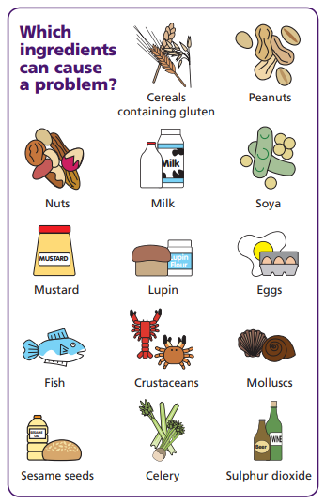

Appendix B - WSU Risk Assessment Cleaning Up Bodily Fluids (Blood, Vomit)

