# **Candidate Budget Sheet 2025**

## Please record your spending below and attach **all** receipts for expenditure. The maximum amount you can claim is as follows:

|  |  |
| --- | --- |
| Amount the Students’ Union will reimburse a candidate for: | £20 |
| Additional spend allowed: | £20 |
| **Total Candidate Budget 2025:** | **£40** |

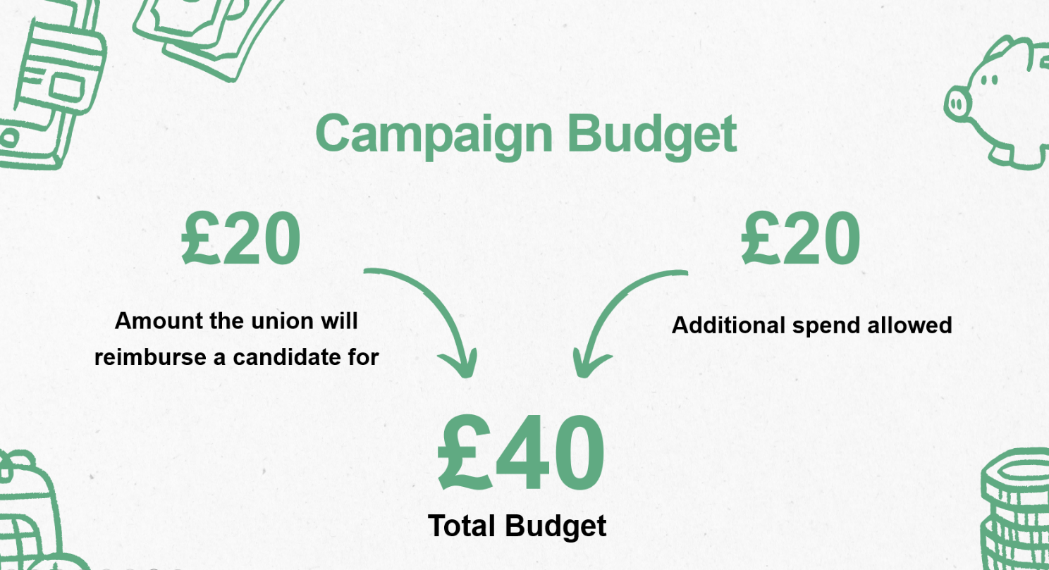

You must detail **all** expenditure that you have spent out of your allowance.

If you are running in a slate, any promotional material used to promote both/all candidates e.g., a social media post advertising more than one candidate, the cost must be included against each candidate.

All claims must be approved by the Deputy Returning Officer.

Students’ Union Printing Costs (via SU Welcome Desk during opening hours/weekdays):

* B/W A4 printing costs £0.05 (Double Sided £0.07)
* Colour A4 printing costs £0.10 (Double Sided £0.15)
* B/W A3 printing costs £0.10 (Double Sided £0.15)
* Colour A3 printing costs £0.20 (Double Sided £0.30)

Set price items:

|  |  |  |  |
| --- | --- | --- | --- |
| Self-decorated,  pre-owned t-shirts | £2 per t-shirt | Preowned costumes | £5 per costume |
| Photo Frames / Wooden Frames pre-owned | £1 per frame | Pre-owned bedsheet | £1 per bedsheet |
| Sweet Wrappers pre-owned | £1 per 100 wrappers | Sweets (pre-owned) | £2 per 800g (large bucket) |
| Ribbon | £2 per 10 metre roll |  |  |

Items that all candidates could reasonably get for free e.g., cardboard boxes, glue, pens and pencils do not need to be included. Full guidance can be found in the Election Rules in the Candidate Information Hub.

Free to use items:

|  |  |  |  |
| --- | --- | --- | --- |
| Any standard stationary item | Including pens, pencils, paper, card, sticky notes, pushpins, tape, cardboard, glue, string | Handmade posters | Must not be printed / use any form of printing and must use items from the ‘any standard stationary item’ list |

Not free to use:

|  |  |  |  |
| --- | --- | --- | --- |
| Personal printers | Not all students have access to personal printers, and they are considered expensive items. For this reason, all printing should go through the SU or a method where a receipt / charge can be given | Use of vehicles (for the purpose of campaigning, not for general travel) | Not all students have access to a car or vehicle, so using these items to campaign (e.g. putting a banner across a car and driving it around campus) is not permitted |

|  |  |  |  |  |
| --- | --- | --- | --- | --- |
| **Date** | **Item** | **Cost** | **Total** | **Budget remaining** |
|  |  |  |  |  |
|  |  |  |  |  |
|  |  |  |  |  |
|  |  |  |  |  |
|  |  |  |  |  |
|  |  |  |  |  |
|  |  |  |  |  |

**Please download a second sheet if needed.**

**I confirm that the above spending record is a true and accurate.**

Print name: ________________________ Position stood for: ____________________________

Signature: _________________________ Date: _____/_____/_____

**Approved: YES/NO Amount:**

**Signed (DRO):** ……………………………………………………………………………………

|  |  |
| --- | --- |
| **Address Details** | |
|  | |
| **Bank Details** | |
| Bank of Building Society: |  |
| Account Name: |  |
| Sort Code: |  |
| Account Number: |  |

Please note that monies will be reimbursed by BACS transfer following approval of your claim.

**Please return this form (with ALL itemised receipts) to the Students’ Union Welcome Desk (SU Building, St Jhon’s Campus) by 17:30 on Thursday 27th February 2025.**